Kirby Bulk and Brush Information

* **Brush/Bulky Guidelines:**
* Limit your brush pile to **Three (3) cubic yards**.
* Brush must be placed within five (5) feet of the curb.
* Do not place brush piles in front of parked cars, near fences, trees, mailboxes, beneath overhead wires, low-hanging tree limbs, or on top of gas/water meters.
* If glass windows or doors are placed at the curb they must be taped up to prevent it from shattering upon pickup
* Brush must be set out **no later than 7:00 a.m. on the first day of your scheduled collection week.**
* Do not place material at the curb after crews have passed by your house.

**Accepted Materials**

* Shrubs, Tree Branches, Woody Vines, Other herbaceous and woody plants, BBQ grills(without compressed gas tanks), Carpeting, Fencing, Furniture, Mattresses, Toilets, Water heaters, Appliances***

**\*\*\*Refrigerators, freezers, and a/c window units will be collected only if refrigerant has been removed and the appliance is tagged and certified, indicating removal of refrigerant\*\*\***

**Materials Not Accepted**

* Household Trash, Construction Debris –(*This includes, but is not limited to, brick, concrete, other masonry materials, stone, glass, drywall, framing and finishing lumber, roofing materials, plumbing fixtures, HVAC equipment, insulation, and wall-to-wall carpeting)*, Hazardous Materials (paints, household cleaners, oil,), Compressed Gas Tanks, Tires, Televisions, Electronics, Computers, Medical Waste, Appliances with refrigerant that has not been removed and certified. Automotive parts or any machinery that may contain gasoline or oil.

**Sector 1- Sept 2nd – 6th All Homes south of Binz Engleman Rd**

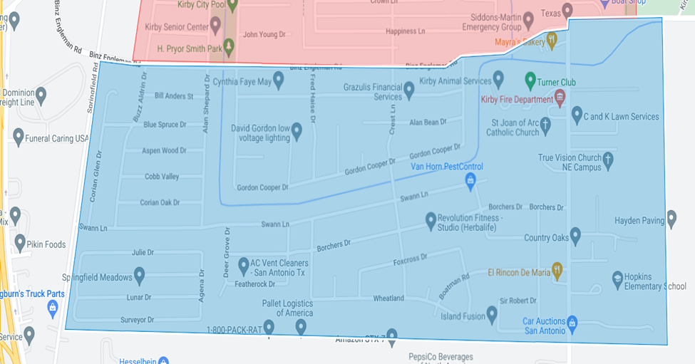

**Sector 2- September 9-13 All homes north of Binz Engleman Rd**

